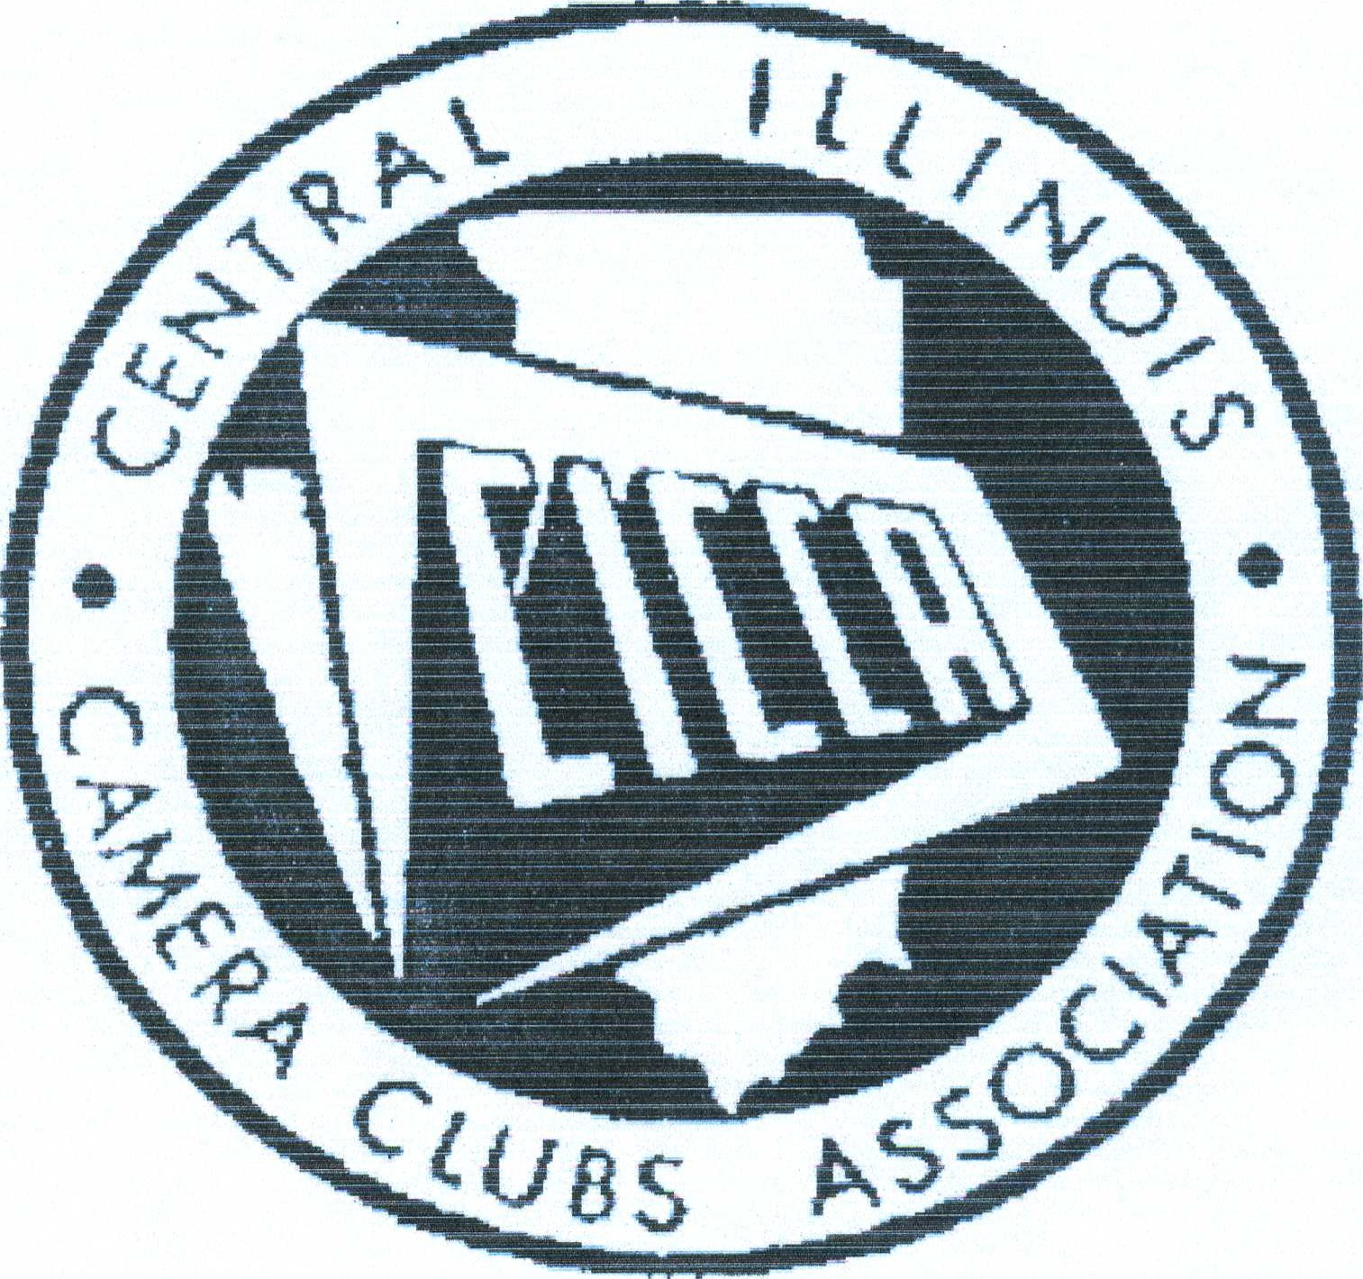
CENTRAL ILLINOIS CAMERA CLUBS
ASSOCIATION
REPRESENTATIVE HANDBOOK
2010 Edition

GENERAL REPRESENTATIVE INSTRUCTIONS

TABLE OF CONTENTS

INTRODUCTION TO CICCA 3
HISTORY OF CICCA 4
MEMBER CLUBS 5
CICCA CLUB REPS AND DUTIES 6
MEMBER CLUB REPORT 9
COURIER INFORMATION 10
CICCA HONOR AWARD 11
HONOR QUALIFICATIONS 12
PROPOSER'S STATEMENT FORM 13
ENDORSER'S STATEMENT FORM 14

CICCA REPS HANDBOOK, JAN. 01, 1999 (UPDATED 2005, 2009, 2010)

INTRODUCTION
This is an introduction to the Central Illinois Camera Clubs Association, known as CICCA to the members of the 16 clubs throughout the central Illinois area from the Indiana border on the east to the west side of the Mississippi River in Iowa. The membership rolls in CICCA clubs range from a handful to well over 100.
It is also an introduction to new clubs, new presidents and especially new representatives (CICCA reps) who we hope will become a solid link in the chain that connects all CICCA clubs. We are sure you will enjoy this association of photographers. If you have questions which are not answered within these pages please ask any person who has belonged to CICCA for a few years.
Please read carefully the suggested routines for CICCA reps and follow them as closely as possible. This will bring you in touch with CICCA policies and procedures, the CICCA Courier, the annual Fall Club Salon and business meeting, the Spring Individual Salon, and more importantly, the secretary of CICCA. As this is being written, CICCA is in the process of making changes to how its Salons are organized so please make careful note of messages that may be sent from time to time with regard to this handbook.
This guideline book is the result of over three years of study and preparation. Unfortunately we may have left out some information you consider important. Ask us and we will try to include it in future editions.
We hope you have a long and pleasant association with CICCA.

HISTORY

The idea of an organization of camera clubs to promote the photographic interests of the clubs and their members was in the dreams of several Illinois amateur photographers as early as 1945. Included in the group of dreamers were Clarence Einhaus, Frank Fuller, Spee Wright and Dale Greffe. Each was actively, though separately, trying to promote such an organization.
By early 1950, as a result of very hard efforts by Spee Wright, the foundation of what was to become known as the Central Illinois Camera Clubs Association was formed. While in its early stages of development, this early structure was to undergo considerable change. Sam Levy of the Decatur Camera Club was elected the first president to serve until the fall meeting which was held in November, 1950. Shortly thereafter a constitution was formed and adopted and CICCA arranged for appropriate legal status. Starting with only ten clubs, CICCA now boasts an active membership of sixteen clubs, representing many amateur photographers.
Since 1950, a Fall Club Salon providing competition in both color and monochrome has been held annually. CICCA holds two contest salons annually: a Spring Individual Salon in early May, and a Fall Club Salon usually held during the first two weeks of November. CICCA member clubs take turns hosting these salons in various cities.
The first picnic, which was to become an annual affair, was held in June, 1952. In 1954, President Evelyn M. Robbins almost single handedly promoted the first CICCA weekend conference. In recent years the picnic and weekend conference have been discontinued.
Time and space do not permit identification of all the services that have been or are now provided for the member clubs of CICCA. It is sufficient to note that in the brief span of almost six decades CICCA has become known the country over for its record of service to its member clubs and to amateur photography in general.
Such a record of achievement could not have been possible without the unselfish efforts of many faithful individuals. For their contributions both large and small, which are documented in the records of the organization, CICCA expresses its grateful appreciation.
(This history is based on a history written in 1961 by Dale Greffe.)
Minor revisions January 18, 2010 by Hiram Paley

MEMBER CLUBS
CLUB # | CLUB NAME | CITY
02 | CHAMPAIGN COUNTY CAMERA CLUB | URBANA, IL
06 | PHOTOGRAPHY UNLIMITED | PRINCETON, IL
07 | DECATUR CAMERA CLUB | DECATUR, IL
11 | KEOKUK CAMERA CLUB | KEOKUK, IA
12 | KODA ROAMERS CAMERA CLUB | BLOOMINGTON, IL
14 | PEORIA CAMERA CLUB | PEORIA, IL
15 | SHUTTERBUG CAMERA CLUB | BURLINGTON, IA
16 | PHOTOCOLORISTS | BLOOMINGTON, IL
17 | PHOTOCRAFTERS CAMERA CLUB | MOLINE, IL
19 | PHOTOGRAPHY SOCIETY OF QUINCY | QUINCY, IL
22 | SPRINGFIELD CAMERA CLUB | SPRINGFIELD, IL
24 | STREATOR CAMERA CLUB | STREATOR, IL
30 | GREAT RIVER CAMERA CLUB | MUSCATINE, IA
31 | MORRIS CAMERA CLUB | MORRIS, IL
36 | QUAD CITIES CAMERA CLUB | MOLINE, IL
37 | GALESBURG CAMERA CLUB | GALESBURG, IL

Each CICCA affiliated camera club shall have one CICCA representative (rep). Each club shall determine the manner of choosing its representative. For each club, it is recommended its CICCA rep be a member of its board of directors. The primary duty of a CICCA rep is to expedite communication between CICCA and the rep's club, and to fulfill various responsibilities to enable CICCA to operate smoothly.
Duties of a CICCA Representative
- Provide information to CICCA officers as needed.
  - When CICCA holds a vote by US mail or e-mail, the rep shall report the vote of his/her club to the secretary by the deadline set by the CICCA secretary.
  - The rep will keep the CICCA secretary informed of any change in the club's officers, including their contact information.
- Explain to club members the purposes of CICCA and the responsibilities of the club to CICCA.
- Furnish the editor of the CICCA Courier with news items of the club's activities by the editor's deadline.
- Make certain that all members of the rep's club receive copies of the CICCA Courier either in printed form or by e-mail.
- For the annual salon, the rep will make sure all of the club's entries are properly prepared for transmission to the appropriate people in CICCA responsible for that fall's salon.
- Attend and participate in all CICCA business meetings. Participate in CICCA meetings by voting, presenting local club concerns and helping to plan CICCA activities. At local club meetings, report on business transacted at CICCA meetings. If the club's rep is unable to attend a CICCA meeting, the rep shall delegate the rep's duties to a club member who is able to attend the meeting. This alternate CICCA rep should have written authority from the CICCA rep to represent his/her club at the business meeting.
All CICCA reps are encouraged to attend the annual business meeting during the annual fall salon, and other called meetings. A mid-year meeting is usually held in a centrally located town during March.
CICCA meetings are of importance to both the representatives and their member clubs: at the meetings, the reps take part in the business activities of CICCA as members of the Board of Directors, work with the officers, committee personnel and other reps, and learn of dates and locations of future CICCA events. At the annual business meeting and the mid-year meeting, a quorum of 40 % of the CICCA representatives is needed to elect officers and to approve all business matters.
TIME TABLE FOR DUTIES OF CICCA REPRESENTATIVE
Throughout the year: Each rep is responsible for sending his/her club news in time to reach the CICCA Courier editor for publication in the CICCA Courier. Following the publication of the Courier, the rep is responsible for sending his/her club's members copies of the Courier. E-mail copies may be sent to those members with e-mail capability; hard copies should be sent to other club members. Currently, the Courier is published in September, December, March and May. Information should reach the editor by the 15th of the month prior to the month of publication (i.e., Aug, Nov, Feb & Apr). The Courier will be published (sent to reps by e-mail) on the 10th of the month of publication.
March:
CICCA holds a mid-year meeting each March. Each rep should attend the meeting or arrange for a substitute to attend. CICCA business is conducted at this meeting so it is important for reps to make sure their clubs are represented.
Reps should remind their members of the CICCA Individual Salon held in May and should help members understand how to enter.
Reps should consider suitable nominees for CICCA honor awards. Nominations should be sent to the honors committee chairperson to arrive by June 1, Qualifications for these awards are shown elsewhere in the rep’s handbook.
September:
Reps should discuss the CICCA Fall Salon with their clubs. The rep should be fully aware of how a club enters the two divisions of the fall salon. He/she should be fully aware of the salon location and have directions on how to reach the venue. The rep should receive information through the Courier and from the CICCA secretary concerning the salon, and
Official entry forms for the fall salon are to be prepared early in the month by the rep or he/she should have available for distribution official print stickers.
October:
designated member or members of the club. The rep must make sure that all salon materials for his/her club (prints, slides; digital images on CD's) are shipped to the appropriate people in the salon host club to meet all deadlines.
November:
The rep should attend the CICCA annual salon & business meeting. If unable to attend the meeting, the rep should appoint an alternate CICCA rep with written authority to represent the club. At the meeting, the rep will vote on election of new CICCA officers, executive board members, and any other business motions.

November or December:
The rep should report on the annual salon and meeting to his/her club. The rep should also complete the back of any ribbons awarded at the salon and give them to the appropriate club members.
As Appropriate:
When a club has elected its new officers, the rep should report this information to the CICCA secretary.
If a club has a website, the rep should send the CICCA webmaster the URL for that website so a link can be posted on the CICCA website.
The form on the next page or a reasonable alternative should be used for reporting the names and contact information for club officers and other club information to the CICCA secretary.
CENTRAL ILLINOIS CAMERA CLUBS ASSOCIATION
MEMBER CLUB REPORT
Whenever a club elect’s new officers, please complete a copy of this form and return it to the CICCA secretary.
CLUB ___________________________________________ CLUB NO. ______________
CITY
MO / MO
PRESIDENT _____________________________ TELEPHONE______________

ADDRESS ___________________________________________________________________

E-MAIL ADDRESS: ____________________________________________________

VICE-PRESIDENT _________________________ TELEPHONE __________________

ADDRESS ____________________________________________________________

E-MAIL ADDRESS: ____________________________________________________

SECRETARY _____________________________ TELEPHONE___________________

ADDRESS ____________________________________________________________

E-MAIL ADDRFSS ____________________________________________________________

CICCA REP. __________________________________ TELEPHONE _______________

ADDRESS ____________________________________________________________

E-MAIL ADDRESS: ____________________________________________________

MEETING DATES ____________________________________ TIME _______________

MEETING LOCATION _____________________________________________________

APPROXIMATE MEMBERSHIP __________________ INTERESTS: ( ) Prints ( ) Digital

Please list anyone in your club that may be interested in judging, giving a program or serving on a CICCA committee.
NAME ACTIVITY
______________________________________ __________________________

REMARKS: ______________________________________________________________

REPORT PREPARED BY: ___________________________________________

DATE: ______________

CICCA COURIER
The CICCA Courier is published four times a year for member clubs. The CICCA Courier is an important form of communication for all the clubs. This newsletter contains vital information such as: salon information, area seminars / workshops sponsored by area clubs, judging statistics, and general club news from the reps.
Each rep is encouraged to send club news, reporting anything of interest to all members of CICCA concerning his/her club, awards received by club members, programs, salons, and special meetings. Be sure spelling of names and CICCA honors (ACICCA, FCICCA, etc.) are correct. Feel free to make suggestions to improve the newsletter. If you can, add a picture for your story, especially if it's really newsworthy.
Remember a good "reporter" always asks: who? what? when? where? why? how?
For your convenience, here is the current publication schedule of the Courier. Please follow this schedule so your club's news will reach the editor by deadlines:

EDITOR'S DESK BY | FOR
FEBRUARY 15TH | MARCH ISSUE
APRIL 15TH | MAY ISSUE
SEPTEMBER 15TH | OCTOBER ISSUE
NOVEMBER 15TH | DECEMBER ISSUE
In case you must be a few days late, please notify the editor as early as possible.
The current editor of the Courier is MARY De CATELL, 1511 ALMA DRIVE,
CHAMPAIGN, IL 61820. PHONE: 217-359-3050. E-MAIL: mary@cattell.com

CENTRAL ILLINOIS CAMERA CLUBS ASSOCIATION
HONOR AWARD INSTRUCTIONS

These honors are awarded in recognition of contributions to the promotion of amateur photography by services to CICCA and CICCA member clubs; and for individual achievements in the art of photography.
Except for the honorary member award, all applications for CICCA honors consideration must be made on the official honors application form and sent to the chairperson of the honors committee. The deadline for receipt of all applications is August 1.
Only members in good standing in CICCA member clubs can make nominations for CICCA honors consideration. A proposer is not limited to nominating people only from his/her club, but may nominate any qualified person who is a member of any CICCA club.
In addition to the proposer, each application shall be endorsed by at least one additional member of a CICCA club in good standing. Such endorsement(s) shall be sent directly to the honors committee chairperson.
Award Qualifications
Associateship (ACICCA):
The associateship is restricted to the membership of CICCA member clubs and is intended for services to CICCA and its member clubs. Individual achievements may be considered with such services. Election to the associate grade requires a favorable vote by a majority of the seven members of the honors committee.
Fellowship (FCICCA):
The fellowship is awarded for outstanding services to CICCA and its member clubs. This grade requires a reasonable degree of individual achievements in the art of photography and is limited to those having previously received an associateship. It is restricted to members of CICCA member clubs, and requires favorable votes by a majority of the seven members on the honors committee.
Honorary membership:
This grade of membership is intended for persons not members of CICCA affiliated clubs and requires no dues. Election to this grade requires a majority vote of the honors committee for recommendation to the CICCA Board of Directors and a 90 percent affirmative approval vote of the Board. (See CICCA by-laws Article XI, Section 2). The honorary membership is CICCA's recognition for special services to CICCA or its member clubs.

Honorary fellowship:
The honorary fellowship is awarded for very outstanding services to CICCA and to amateur photography as a whole. The recipient may be a member of a CICCA member club or not. Six votes out of seven are needed for recommendation to the Board of Directors and a 90 percent affirmative approval vote of the Board for election. (See bylaws, Article XI, Section 2). The number of living honorary fellows is limited to ten.
Examples of qualifications required for an honor award:
1. Club affiliation and activities: length of such affiliation, offices held, committee activities, lectures, demonstrations.
2 Service to CICCA: offices held, committee activities, other services.
- Services to CICCA member clubs: programs, judging, lectures, other services.
- Achievements in the arts of photography.
Nature of achievement: salon record, special or invitational exhibitions, special techniques shared with others, other special achievements.
The ability to pass judgment on technical research and related areas involving the science of photography is outside the scope of CICCA.
Instructions to Proposers
If, after reading the qualifications described above for the various awards, you are convinced your candidate is qualified for the honor requested, accurately complete the Proposer's form. Present the facts in a clear and concise manner. Do not use flowery language or resort to exaggeration.
It is the duty of the proposer to do the following:
A: Prepare the Proposer's Statement Form.
B: Secure one Endorser and make certain the Endorser prepares and sends to the Chairperson of the honors committee the Endorser's statement.
Note: as a general rule, the candidate should remain unaware an honor has been proposed for him/her. Address all communications relating to honors to the chairperson of the honors committee.

Central Illinois Camera Clubs Association
Honor Award
Proposer's Statement
Nominee's name: _________________________________

Honor proposed
Proposer's name:
Proposer's address:
How long has the Proposer known the Nominee?
In a few brief and concise statements, using additional pages if needed, explain the Nominee's qualifications and accomplishment which qualify him/her for the honor for which he/she is being proposed. Include dates and places for the person's accomplishments, where possible. An MS Word version of this form should be obtained from the CICCA Secretary or Chair of the Honors Committee and completed as an MS Word document. However, if that is not possible, a typewritten version may be completed, in which case a photocopy should be retained by the Proposer.

Proposer’s Signature ____________________________________ Date: ______________
Central Illinois Camera Clubs Association
Honor Award
Endorser's Statement
Nominees's name:
Endorser' s name:
Endorser's address:
How long has the endorser known the applicant?
In a brief and concise statement explain why you think the nominee qualifies for the honor for which he/she has been proposed. This form must be typewritten or an MS Word version of this form should be obtained from the CICCA Secretary or Chair of the Honors Committee and your information can be typed into the MS Word document. Complete a photocopy of this form, if it is typewritten.

Endorser's signatureDate

